**CN LAB2**

**Shreyansh-1BM22CS419**

Configure IP address to routers in packet tracer. Explore the following messages: ping responses, destination unreachable, request timed out, reply.

**TOPOLOGY:**

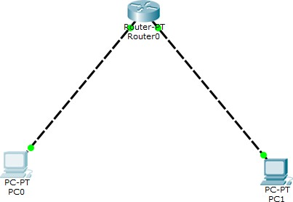

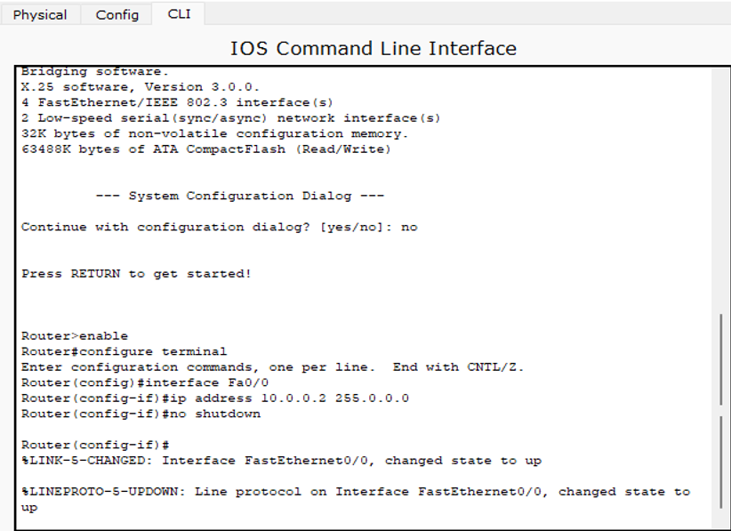

**OUTPUT WITHOUT SETTING DEFAULT GATEWAY**:

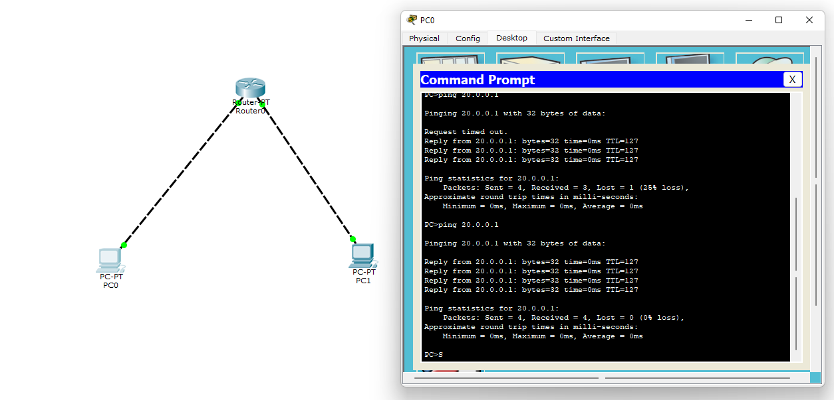

**OUTPUT AFTER SETTING DEFAULT GATEWAY**

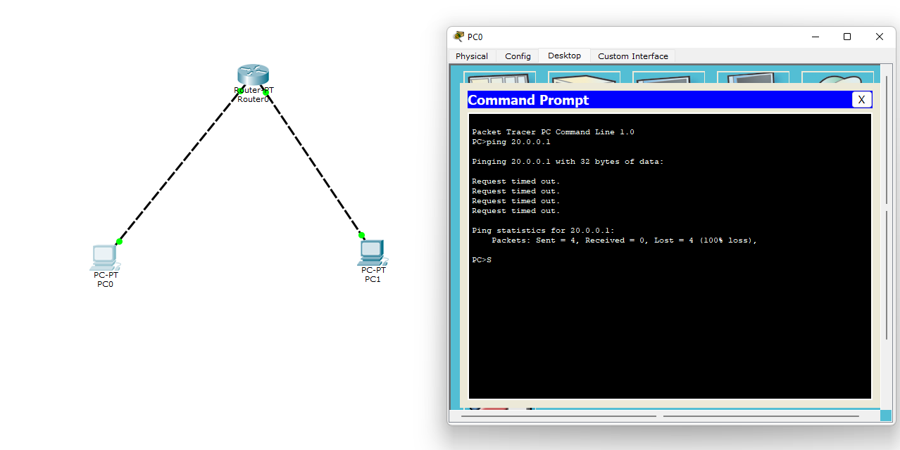

**OUT COMES:**

1. Ping Responses: The configured IP address of the destination device is correct and the network connection is functioning properly thus, we receive a successful ping response. This indicates that the destination device is reach able and responsive.
2. Without setting default gateway for the end devices: Request Timed Out-

"Request Timed Out" message: thus-the router sent a request but did not receive a response within a specific time frame.

1. After setting default gateway for end devices- Reply from: 4 “Reply from..32bytes” messages are seen. Router has received a valid message or request and thus it generates a reply to acknowledge the receipt. A reply message confirms that the communication is established and the router is functioning properly.